SCHOOL OF ENGINEERING & TECHNOLOGY
BACHELOR OF TECHNOLOGY
COMPILER DESIGN
6TH SEMESTER
DEPARTMENT OF COMPUTER SCIENCE & ENGINEERING

Laboratory Manual

TABLE OF CONTENT
Sr. No | Experiment Title
1 |  | - Write a program to recognize strings starts with ‘a’ over {a, b}.  - Write a program to recognize strings end with ‘a’.  - Write a program to recognize strings end with ‘ab’. Take the input from text file.  - Write a program to recognize strings contains ‘ab’. Take the input from text file.
2 |  | - Write a program to recognize the valid identifiers.  - Write a program to recognize the valid operators.  - Write a program to recognize the valid number.  - Write a program to recognize the valid comments.  Program to implement Lexical Analyzer.
3 |  | To Study about Lexical Analyzer Generator (LEX) and Flex(Fast Lexical Analyzer)
4 |  | Implement following programs using Lex.  a. Write a Lex program to take input from text file and count no of characters, no. of lines & no. of words.  b. Write a Lex program to take input from text file and count number of vowels and consonants.  c. Write a Lex program to print out all numbers from the given file.  d. Write a Lex program which adds line numbers to the given file and display the same into different file.  e. Write a Lex program to printout all markup tags and HTML comments in file.
5 |  | a. Write a Lex program to count the number of C comment lines from a given C program. Also eliminate them and copy that program into separate file.  b. Write a Lex program to recognize keywords, identifiers, operators, numbers, special symbols, literals from a given C program.
6 |  | Program to implement Recursive Descent Parsing in C.
7 |  | a. To Study about Yet Another Compiler-Compiler(YACC).  b. Create Yacc and Lex specification files to recognizes arithmetic expressions involving +, -, * and / .  c. Create Yacc and Lex specification files are used to generate a calculator which accepts integer type arguments.  d. Create Yacc and Lex specification files are used to convert infix expression to postfix expression.

Practical-1
- Write a program to recognize strings starts with ‘a’ over {a, b}.
Input:
#include<stdio.h>
int main ()
{
char input[10];
int state=0,i=0;

printf("Enter the input string : ");
scanf("%s",input);

while(input[i]!='\0'){
switch (state){
case 0:
if (input[i]=='a'){
state = 1;
i++;
}
else if (input[i]=='b'){
state = 2;
i++;
}
else {
state = 3;
i++;
}
break;
case 1:
if (input[i]=='a'||input[i]=='b'){
state = 1;
i++;
}
else {
state = 3;
i++;
}
break;
case 2:
if (input[i]=='a'||input[i]=='b'){
state = 2;
i++;
}
else {
state = 3;
i++;
}
break;
case 3:
state=3;
i++;
break;
}
}
printf("State is %d",state);
return 0;
}

Output:
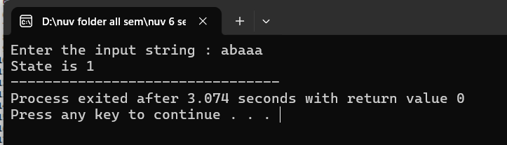

Input (With File) (extra practical):

#include<stdio.h>
#include <stdlib.h>
int main ()
{
char input[100];
int state=0,i=0;
//write a program for string starts with 'a'.
FILE* ptr;

ptr = fopen("Hello.txt", "r");

if (ptr == NULL)
{
printf("Error While opening file");
exit(1);
}

if(fgets(input, 80, ptr) != NULL)
{
puts(input);
}
fclose(ptr);
printf("\nInput is : %s ",input);

// printf("Enter : ");
// scanf("%s",input);

while(input[i]!='\0'){
switch (state){
case 0:
if (input[i]=='a'){
state = 1;
i++;
}
else {
state = 2;
i++;
}
break;
case 1:
state = 1;
i++;
break;
case 2:
state = 2;
i++;
break;
}
}
if(state == 1){
printf("\nThe String is valid.",input);
}
else if(state == 2){
printf("\nThe String is invalid.",input);
}
printf("\nState is %d",state);
return 0;
}

Output:
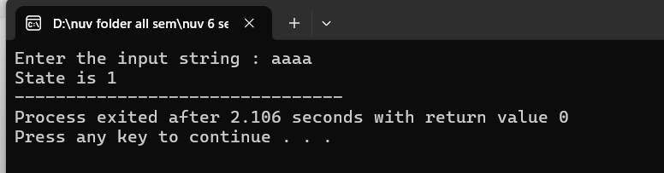

- Write a program to recognize strings end with ‘a’.
Input:
#include<stdio.h>
#include <stdlib.h>
int main ()
{
char input[100];
int state=0,i=0;
//write a program for string ends with 'a'.
FILE* ptr;

ptr = fopen("Hello.txt", "r");

if (ptr == NULL)
{
printf("Error While opening file");
exit(1);
}

if(fgets(input, 80, ptr) != NULL)
{
puts(input);
}
fclose(ptr);
printf("\nInput is : %s ",input);

// printf("Enter : ");
// scanf("%s",input);

while(input[i]!='\0'){
switch (state){
case 0:
if (input[i]=='a'){
state = 1;
i++;
}
else {
state = 0;
i++;
}
break;
case 1:
if (input[i]=='a'){
state = 1;
i++;
}
else{
state = 0;
i++;
}
break;
case 2:
state = 2;
i++;
break;
}
}
if(state == 1){
printf("\nThe String is valid.",input);
}
else if(state == 0){
printf("\nThe String is invalid.",input);
}
printf("\nState is %d",state);
return 0;
}
Output:
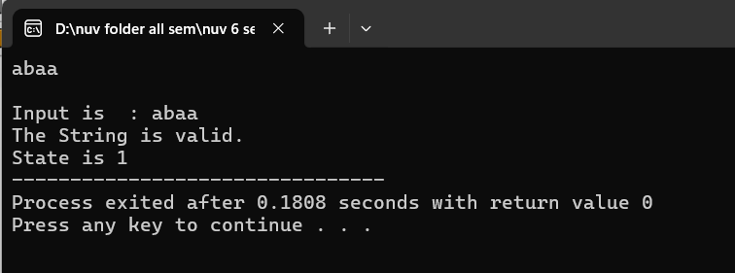

- Write a program to recognize strings end with ‘ab’. Take the input from text file.
Input:
//string ends with ab and take input from a file.
#include <stdio.h>

int main() {
char input[100];
int state = 0, i = 0;
FILE *file; // File pointer

file = fopen("input.txt", "r");
if (file == NULL) {
printf("Error: Could not open file.\n");
return 1;
}

if (fgets(input, sizeof(input), file) == NULL) {
printf("Error: Could not read from file or file is empty.\n");
fclose(file);
return 1;
}

fclose(file);

// Removing newline character, if present
for (i = 0; input[i] != '\0'; i++) {
if (input[i] == '\n') {
input[i] = '\0';
break;
}
}

i = 0; // Reset index for processing the string

while (input[i] != '\0') {
switch (state) {
case 0:
if (input[i] == 'a') {
state = 1;
} else if (input[i] == 'b') {
state = 0;
} else {
state = 0;
}
break;
case 1:
if (input[i] == 'b') {
state = 2;
} else if (input[i] == 'a') {
state = 1;
} else {
state = 0;
}
break;
case 2:
if (input[i] == 'a') {
state = 1;
} else if (input[i] == 'b') {
state = 0;
} else {
state = 0;
}
break;
}
i++;
}

if (state == 0) {
printf("String is invalid.\n");
printf("The state is: %d\n", state);
} else if (state == 1) {
printf("The string is invalid.\n");
printf("The state is: %d\n", state);
} else if (state == 2) {
printf("The string is valid.\n");
printf("The state is: %d\n", state);
}

return 0;
}

Output:
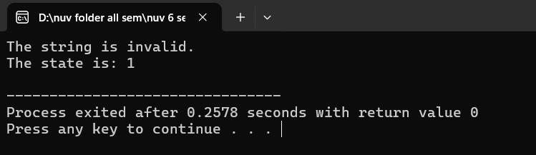

d) Write a program to recognize strings contains ‘ab’. Take the input from text file.
Input:
#include <stdio.h>
#include <string.h>

#define MAX_LINE_LENGTH 100 // Maximum length for each line

// Function to check strings containing "ab"
void checkStringsContainingAb(const char *filePath) {
FILE *file = fopen(filePath, "r"); // Open the file in read mode
if (file == NULL) {
printf("Error: Could not open file '%s'\n", filePath);
return; // Exit the function if the file cannot be opened
}

char line[MAX_LINE_LENGTH]; // Buffer to hold each line
printf("Strings that contain 'ab':\n");

// Read each line from the file
while (fgets(line, sizeof(line), file) != NULL) {
// Remove the trailing newline character if present
size_t len = strlen(line);
if (len > 0 && line[len - 1] == '\n') {
line[len - 1] = '\0';
}

// Check if the string contains "ab"
if (strstr(line, "ab") != NULL) {
printf("%s\n", line);
}
}

fclose(file); // Close the file
}

int main() {
char filePath[100];

// Prompt the user for the input file path
printf("Enter the path to the text file: ");
scanf("%s", filePath);

// Call the function to check strings
checkStringsContainingAb(filePath);

return 0;
}
Output:
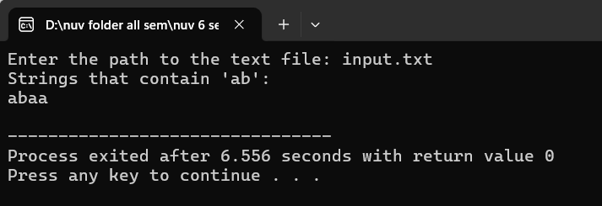

e) Write a program to recognize strings that starts with ‘//’ (Comments). Take the input from text file (extra practical).
Input: (Single line code)
#include <stdio.h>
#include <stdlib.h>
#include <string.h>

#define MAX_LINE_LENGTH 256

// Function to check if a line starts with "//"
int isComment(const char *line) {
// Check if the line starts with '//' and is not empty
if (line[0] == '/' && line[1] == '/') {
return 1;
}
return 0;
}

int main() {
char filename[100];
char line[MAX_LINE_LENGTH];

printf("Enter the filename: ");
scanf("%s", filename);

// Open the file in read mode
FILE *file = fopen(filename, "r");
if (file == NULL) {
printf("Error: Could not open file %s\n", filename);
return 1;
}

printf("Lines that start with '//' (Comments):\n");

// Read the file line by line
while (fgets(line, sizeof(line), file)) {
// Remove the newline character from the line if it exists
line[strcspn(line, "\n")] = 0;

// Check if the line starts with "//"
if (isComment(line)) {
printf("%s\n", line);
}
}

// Close the file
fclose(file);

return 0;
}
Output:
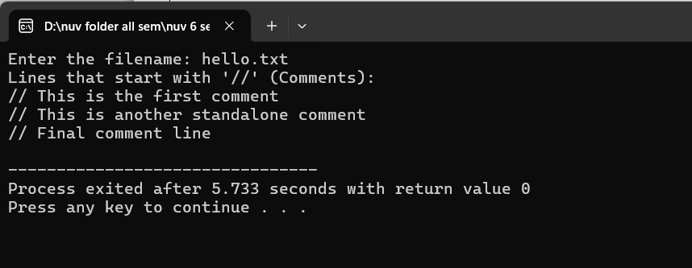

Input: (Multi line code)
//accept only comments single line and multiline both.
#include<stdio.h>
int main(){

char input[100];
int state =0, i=0;
FILE *file;

file = fopen("p1(e)with multiple line.txt","r");
if(file==NULL){
printf("Error: Couldn't open the file.\n");
return 1;
}

if(fgets(input,sizeof(input),file)==NULL){
printf("Error: Couldn't read the file or file is empty.");
fclose(file);
return 1;
}
fclose(file);

for (i = 0; input[i] != '\0'; i++) {
if (input[i] == '\n') {
input[i] = '\0';
break;
}
}

i = 0;

while(input[i]!='\0'){
switch(state){
case 0:
if(input[i]=='/')state = 1;
else state =3;
break;
case 1:
if(input[i]=='/') state=2;
else if(input[i]=='*') state =4;
else state=3;
break;
case 2:
state = 2;
break;
case 3:
state =3;
break;
case 4:
if(input[i]='*')state=5;
else state=4;
break;
case 5:
if(input[i]=='/') state =6;
else state = 4;
break;
case 6:
state = 3;
break;
}
i++;
}
if(state==0){
printf("This is not a comment.");
printf("\nState is %d",state);
}
else if(state==1){
printf("This is not a comment.");
printf("\nState is %d",state);
}
else if(state==2){
printf("This is a single line comment.");
printf("\nState is %d",state);
}
else if(state==3){
printf("This is not a comment.");
printf("\nState is %d",state);
}
else if(state==4){
printf("This is not a comment.");
printf("\nState is %d",state);
}
else if(state==5){
printf("This is not a comment.");
printf("\nState is %d",state);
}
else if(state==6){
printf("This is a multiline comment.");
printf("\nState is %d",state);
}
return 0;
}

Output:
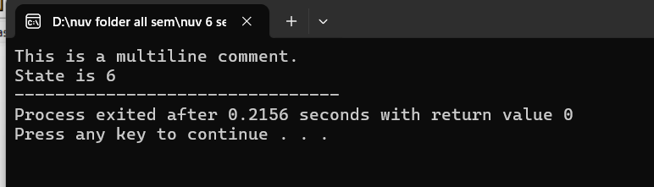
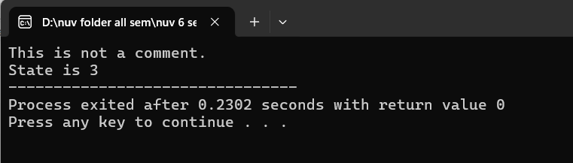

Practical-2
- Write a program to recognize the valid identifiers.
Input:
//Write a program to recognize the valid identifiers.
#include <stdio.h>
#include <ctype.h>
int main()
{
char a[10];
int flag, i=1;

printf("Enter an identifier:");
scanf("%s",&a);

if(isalpha(a[0])){

flag = 1; // If the first character is an alphabet, set flag = 1 (indicating a valid start).

}
else
printf("invalid identifier");

while (a[i] != '\0') {
if (!isalnum(a[i]) && a[i] != '_') {
flag = 0;
break;

}
i++;
}

if(flag == 1){
printf("Valid identifier");
}
//getch();
}

Output:
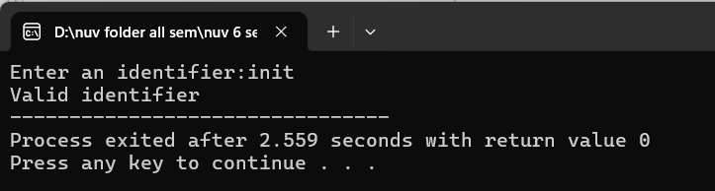

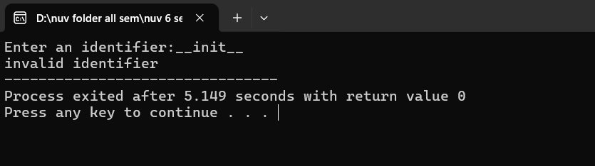

- Write a program to recognize the valid operators.
Input:
//Lexical Analyzer
#include <stdio.h>
#include <stdlib.h>
#include <ctype.h>
#include <string.h>

#define BUFFER_SIZE 1000

void check_keyword_or_identifier(char *lexeme);
void recognize_number(char *lexeme);
void recognize_operator(char c);
void recognize_comment(char *buffer, int *index);

void main() {
FILE *f1;
char *buffer;
char lexeme[50];
char c;
int i = 0, f = 0, state = 0;

f1 = fopen("hello.txt", "r");
if (f1 == NULL) {
printf("Error: Could not open input.txt\n");
return;
}

fseek(f1, 0, SEEK_END);
long file_size = ftell(f1);
rewind(f1);

buffer = (char *)malloc(file_size + 1);

fread(buffer, 1, file_size, f1);
buffer[file_size] = '\0';
fclose(f1);

while (buffer[f] != '\0') {
c = buffer[f];

switch (state) {
case 0:
if (isalpha(c) || c == '_') {
state = 1;
lexeme[i++] = c;
}
else if (isdigit(c)) {
state = 2;
lexeme[i++] = c;
}
else if (c == '/' && (buffer[f + 1] == '/' || buffer[f + 1] == '*')) {
recognize_comment(buffer, &f);
state = 0;
}
else if (strchr("+-*/%=<>!", c)) {
recognize_operator(c);
state = 0;
}
else if (strchr(";,{}()", c)) {
printf("%c is a symbol\n", c);
state = 0;
}
else if (isspace(c)) {
state = 0;
}
break;

case 1:
if (isalnum(c) || c == '_') {
lexeme[i++] = c;
} else {
lexeme[i] = '\0';
check_keyword_or_identifier(lexeme);
i = 0;
state = 0;
f--;
}
break;

case 2:
if (isdigit(c)) {
lexeme[i++] = c;
} else if (c == '.') {
state = 3;
lexeme[i++] = c;
} else if (c == 'E' || c == 'e') {
state = 4;
lexeme[i++] = c;
} else {
lexeme[i] = '\0';
recognize_number(lexeme);
i = 0;
state = 0;
f--;
}
break;

case 3:
if (isdigit(c)) {
lexeme[i++] = c;
} else {
lexeme[i] = '\0';
recognize_number(lexeme);
i = 0;
state = 0;
f--;
}
break;

case 4:
if (isdigit(c) || c == '+' || c == '-') {
state = 5;
lexeme[i++] = c;
} else {
lexeme[i] = '\0';
recognize_number(lexeme);
i = 0;
state = 0;
f--;
}
break;

case 5:
if (isdigit(c)) {
lexeme[i++] = c;
} else {
lexeme[i] = '\0';
recognize_number(lexeme);
i = 0;
state = 0;
f--;
}
break;
}
f++;
}

free(buffer);
}

void check_keyword_or_identifier(char *lexeme) {
int i =0;
char *keywords[] = {
"auto", "break", "case", "char", "const", "continue", "default", "do",
"double", "else", "enum", "extern", "float", "for", "goto", "if",
"inline", "int", "long", "register", "restrict", "return", "short", "signed",
"sizeof", "static", "struct", "switch", "typedef", "union", "unsigned",
"void", "volatile", "while"
};

for (i = 0; i < 32; i++) {
if (strcmp(lexeme, keywords[i]) == 0) {
printf("%s is a keyword\n", lexeme);
return;
}
}
printf("%s is an identifier\n", lexeme);
}

void recognize_number(char *lexeme) {
printf("%s is a valid number\n", lexeme);
}

void recognize_operator(char c) {

char operators[][3] = {"+", "-", "*", "/", "%", "=", "==", "!=", "<", ">", "<=", ">="};
char next = getchar();
char op[3] = {c, next, '\0'};
int i = 0;
for (i = 0; i < 12; i++) {
if (strcmp(op, operators[i]) == 0) {
printf("%s is an operator\n", op);
return;
}
}

printf("%c is an operator\n", c);
ungetc(next, stdin);
}

void recognize_comment(char *buffer, int *index) {
if (buffer[*index] == '/' && buffer[*index + 1] == '/') {
printf("// is a single-line comment\n");
while (buffer[*index] != '\n' && buffer[*index] != '\0') (*index)++;
}
else if (buffer[*index] == '/' && buffer[*index + 1] == '*') {
printf("/* is the start of a multi-line comment\n");
(*index) += 2;
while (!(buffer[*index] == '*' && buffer[*index + 1] == '/') && buffer[*index] != '\0') (*index)++;
if (buffer[*index] == '*' && buffer[*index + 1] == '/') {
printf("*/ is the end of a multi-line comment\n");
(*index) += 2;
}
}
}
Output:
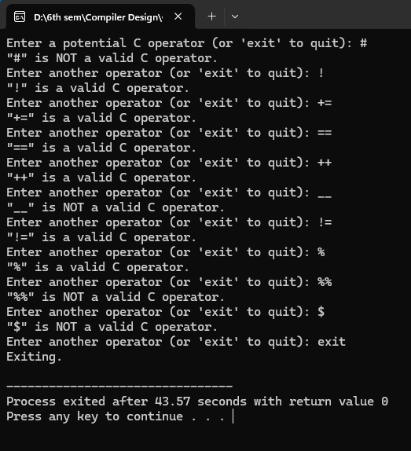

- Write a program to recognize the valid number.
Input:
//Lexical Analyzer
#include <stdio.h>
#include <stdlib.h>
#include <ctype.h>
#include <string.h>

#define BUFFER_SIZE 1000

void check_keyword_or_identifier(char *lexeme);
void recognize_number(char *lexeme);
void recognize_operator(char c);
void recognize_comment(char *buffer, int *index);

void main() {
FILE *f1;
char *buffer;
char lexeme[50];
char c;
int i = 0, f = 0, state = 0;

f1 = fopen("hello.txt", "r");
if (f1 == NULL) {
printf("Error: Could not open input.txt\n");
return;
}

fseek(f1, 0, SEEK_END);
long file_size = ftell(f1);
rewind(f1);

buffer = (char *)malloc(file_size + 1);

fread(buffer, 1, file_size, f1);
buffer[file_size] = '\0';
fclose(f1);

while (buffer[f] != '\0') {
c = buffer[f];

switch (state) {
case 0:
if (isalpha(c) || c == '_') {
state = 1;
lexeme[i++] = c;
}
else if (isdigit(c)) {
state = 2;
lexeme[i++] = c;
}
else if (c == '/' && (buffer[f + 1] == '/' || buffer[f + 1] == '*')) {
recognize_comment(buffer, &f);
state = 0;
}
else if (strchr("+-*/%=<>!", c)) {
recognize_operator(c);
state = 0;
}
else if (strchr(";,{}()", c)) {
printf("%c is a symbol\n", c);
state = 0;
}
else if (isspace(c)) {
state = 0;
}
break;

case 1:
if (isalnum(c) || c == '_') {
lexeme[i++] = c;
} else {
lexeme[i] = '\0';
check_keyword_or_identifier(lexeme);
i = 0;
state = 0;
f--;
}
break;

case 2:
if (isdigit(c)) {
lexeme[i++] = c;
} else if (c == '.') {
state = 3;
lexeme[i++] = c;
} else if (c == 'E' || c == 'e') {
state = 4;
lexeme[i++] = c;
} else {
lexeme[i] = '\0';
recognize_number(lexeme);
i = 0;
state = 0;
f--;
}
break;

case 3:
if (isdigit(c)) {
lexeme[i++] = c;
} else {
lexeme[i] = '\0';
recognize_number(lexeme);
i = 0;
state = 0;
f--;
}
break;

case 4:
if (isdigit(c) || c == '+' || c == '-') {
state = 5;
lexeme[i++] = c;
} else {
lexeme[i] = '\0';
recognize_number(lexeme);
i = 0;
state = 0;
f--;
}
break;

case 5:
if (isdigit(c)) {
lexeme[i++] = c;
} else {
lexeme[i] = '\0';
recognize_number(lexeme);
i = 0;
state = 0;
f--;
}
break;
}
f++;
}

free(buffer);
}

void check_keyword_or_identifier(char *lexeme) {
int i =0;
char *keywords[] = {
"auto", "break", "case", "char", "const", "continue", "default", "do",
"double", "else", "enum", "extern", "float", "for", "goto", "if",
"inline", "int", "long", "register", "restrict", "return", "short", "signed",
"sizeof", "static", "struct", "switch", "typedef", "union", "unsigned",
"void", "volatile", "while"
};

for (i = 0; i < 32; i++) {
if (strcmp(lexeme, keywords[i]) == 0) {
printf("%s is a keyword\n", lexeme);
return;
}
}
printf("%s is an identifier\n", lexeme);
}

void recognize_number(char *lexeme) {
printf("%s is a valid number\n", lexeme);
}

void recognize_operator(char c) {

char operators[][3] = {"+", "-", "*", "/", "%", "=", "==", "!=", "<", ">", "<=", ">="};
char next = getchar();
char op[3] = {c, next, '\0'};
int i = 0;
for (i = 0; i < 12; i++) {
if (strcmp(op, operators[i]) == 0) {
printf("%s is an operator\n", op);
return;
}
}

printf("%c is an operator\n", c);
ungetc(next, stdin);
}

void recognize_comment(char *buffer, int *index) {
if (buffer[*index] == '/' && buffer[*index + 1] == '/') {
printf("// is a single-line comment\n");
while (buffer[*index] != '\n' && buffer[*index] != '\0') (*index)++;
}
else if (buffer[*index] == '/' && buffer[*index + 1] == '*') {
printf("/* is the start of a multi-line comment\n");
(*index) += 2;
while (!(buffer[*index] == '*' && buffer[*index + 1] == '/') && buffer[*index] != '\0') (*index)++;
if (buffer[*index] == '*' && buffer[*index + 1] == '/') {
printf("*/ is the end of a multi-line comment\n");
(*index) += 2;
}
}
}
Output:

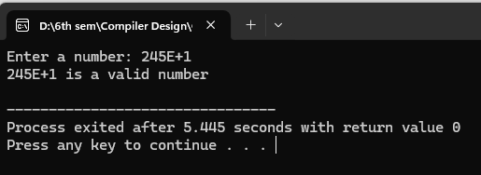

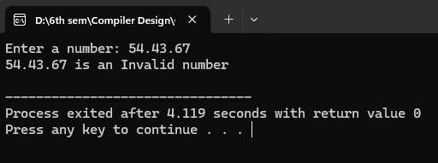

- Write a program to recognize the valid comments.
Input:
//Lexical Analyzer
#include <stdio.h>
#include <stdlib.h>
#include <ctype.h>
#include <string.h>

#define BUFFER_SIZE 1000

void check_keyword_or_identifier(char *lexeme);
void recognize_number(char *lexeme);
void recognize_operator(char c);
void recognize_comment(char *buffer, int *index);

void main() {
FILE *f1;
char *buffer;
char lexeme[50];
char c;
int i = 0, f = 0, state = 0;

f1 = fopen("hello.txt", "r");
if (f1 == NULL) {
printf("Error: Could not open input.txt\n");
return;
}

fseek(f1, 0, SEEK_END);
long file_size = ftell(f1);
rewind(f1);

buffer = (char *)malloc(file_size + 1);

fread(buffer, 1, file_size, f1);
buffer[file_size] = '\0';
fclose(f1);

while (buffer[f] != '\0') {
c = buffer[f];

switch (state) {
case 0:
if (isalpha(c) || c == '_') {
state = 1;
lexeme[i++] = c;
}
else if (isdigit(c)) {
state = 2;
lexeme[i++] = c;
}
else if (c == '/' && (buffer[f + 1] == '/' || buffer[f + 1] == '*')) {
recognize_comment(buffer, &f);
state = 0;
}
else if (strchr("+-*/%=<>!", c)) {
recognize_operator(c);
state = 0;
}
else if (strchr(";,{}()", c)) {
printf("%c is a symbol\n", c);
state = 0;
}
else if (isspace(c)) {
state = 0;
}
break;

case 1:
if (isalnum(c) || c == '_') {
lexeme[i++] = c;
} else {
lexeme[i] = '\0';
check_keyword_or_identifier(lexeme);
i = 0;
state = 0;
f--;
}
break;

case 2:
if (isdigit(c)) {
lexeme[i++] = c;
} else if (c == '.') {
state = 3;
lexeme[i++] = c;
} else if (c == 'E' || c == 'e') {
state = 4;
lexeme[i++] = c;
} else {
lexeme[i] = '\0';
recognize_number(lexeme);
i = 0;
state = 0;
f--;
}
break;

case 3:
if (isdigit(c)) {
lexeme[i++] = c;
} else {
lexeme[i] = '\0';
recognize_number(lexeme);
i = 0;
state = 0;
f--;
}
break;

case 4:
if (isdigit(c) || c == '+' || c == '-') {
state = 5;
lexeme[i++] = c;
} else {
lexeme[i] = '\0';
recognize_number(lexeme);
i = 0;
state = 0;
f--;
}
break;

case 5:
if (isdigit(c)) {
lexeme[i++] = c;
} else {
lexeme[i] = '\0';
recognize_number(lexeme);
i = 0;
state = 0;
f--;
}
break;
}
f++;
}

free(buffer);
}

void check_keyword_or_identifier(char *lexeme) {
int i =0;
char *keywords[] = {
"auto", "break", "case", "char", "const", "continue", "default", "do",
"double", "else", "enum", "extern", "float", "for", "goto", "if",
"inline", "int", "long", "register", "restrict", "return", "short", "signed",
"sizeof", "static", "struct", "switch", "typedef", "union", "unsigned",
"void", "volatile", "while"
};

for (i = 0; i < 32; i++) {
if (strcmp(lexeme, keywords[i]) == 0) {
printf("%s is a keyword\n", lexeme);
return;
}
}
printf("%s is an identifier\n", lexeme);
}

void recognize_number(char *lexeme) {
printf("%s is a valid number\n", lexeme);
}

void recognize_operator(char c) {

char operators[][3] = {"+", "-", "*", "/", "%", "=", "==", "!=", "<", ">", "<=", ">="};
char next = getchar();
char op[3] = {c, next, '\0'};
int i = 0;
for (i = 0; i < 12; i++) {
if (strcmp(op, operators[i]) == 0) {
printf("%s is an operator\n", op);
return;
}
}

printf("%c is an operator\n", c);
ungetc(next, stdin);
}

void recognize_comment(char *buffer, int *index) {
if (buffer[*index] == '/' && buffer[*index + 1] == '/') {
printf("// is a single-line comment\n");
while (buffer[*index] != '\n' && buffer[*index] != '\0') (*index)++;
}
else if (buffer[*index] == '/' && buffer[*index + 1] == '*') {
printf("/* is the start of a multi-line comment\n");
(*index) += 2;
while (!(buffer[*index] == '*' && buffer[*index + 1] == '/') && buffer[*index] != '\0') (*index)++;
if (buffer[*index] == '*' && buffer[*index + 1] == '/') {
printf("*/ is the end of a multi-line comment\n");
(*index) += 2;
}
}
}

Output:
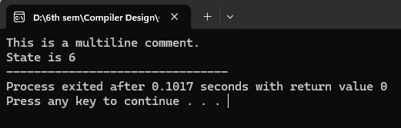

e) Program to implement Lexical Analyzer.
Input:
//Lexical Analyzer
#include <stdio.h>
#include <stdlib.h>
#include <ctype.h>
#include <string.h>

#define BUFFER_SIZE 1000

void check_keyword_or_identifier(char *lexeme);
void recognize_number(char *lexeme);
void recognize_operator(char c);
void recognize_comment(char *buffer, int *index);

void main() {
FILE *f1;
char *buffer;
char lexeme[50];
char c;
int i = 0, f = 0, state = 0;

f1 = fopen("hello.txt", "r");
if (f1 == NULL) {
printf("Error: Could not open input.txt\n");
return;
}

fseek(f1, 0, SEEK_END);
long file_size = ftell(f1);
rewind(f1);

buffer = (char *)malloc(file_size + 1);

fread(buffer, 1, file_size, f1);
buffer[file_size] = '\0';
fclose(f1);

while (buffer[f] != '\0') {
c = buffer[f];

switch (state) {
case 0:
if (isalpha(c) || c == '_') {
state = 1;
lexeme[i++] = c;
}
else if (isdigit(c)) {
state = 2;
lexeme[i++] = c;
}
else if (c == '/' && (buffer[f + 1] == '/' || buffer[f + 1] == '*')) {
recognize_comment(buffer, &f);
state = 0;
}
else if (strchr("+-*/%=<>!", c)) {
recognize_operator(c);
state = 0;
}
else if (strchr(";,{}()", c)) {
printf("%c is a symbol\n", c);
state = 0;
}
else if (isspace(c)) {
state = 0;
}
break;

case 1:
if (isalnum(c) || c == '_') {
lexeme[i++] = c;
} else {
lexeme[i] = '\0';
check_keyword_or_identifier(lexeme);
i = 0;
state = 0;
f--;
}
break;

case 2:
if (isdigit(c)) {
lexeme[i++] = c;
} else if (c == '.') {
state = 3;
lexeme[i++] = c;
} else if (c == 'E' || c == 'e') {
state = 4;
lexeme[i++] = c;
} else {
lexeme[i] = '\0';
recognize_number(lexeme);
i = 0;
state = 0;
f--;
}
break;

case 3:
if (isdigit(c)) {
lexeme[i++] = c;
} else {
lexeme[i] = '\0';
recognize_number(lexeme);
i = 0;
state = 0;
f--;
}
break;

case 4:
if (isdigit(c) || c == '+' || c == '-') {
state = 5;
lexeme[i++] = c;
} else {
lexeme[i] = '\0';
recognize_number(lexeme);
i = 0;
state = 0;
f--;
}
break;

case 5:
if (isdigit(c)) {
lexeme[i++] = c;
} else {
lexeme[i] = '\0';
recognize_number(lexeme);
i = 0;
state = 0;
f--;
}
break;
}
f++;
}

free(buffer);
}

void check_keyword_or_identifier(char *lexeme) {
int i =0;
char *keywords[] = {
"auto", "break", "case", "char", "const", "continue", "default", "do",
"double", "else", "enum", "extern", "float", "for", "goto", "if",
"inline", "int", "long", "register", "restrict", "return", "short", "signed",
"sizeof", "static", "struct", "switch", "typedef", "union", "unsigned",
"void", "volatile", "while"
};

for (i = 0; i < 32; i++) {
if (strcmp(lexeme, keywords[i]) == 0) {
printf("%s is a keyword\n", lexeme);
return;
}
}
printf("%s is an identifier\n", lexeme);
}

void recognize_number(char *lexeme) {
printf("%s is a valid number\n", lexeme);
}

void recognize_operator(char c) {

char operators[][3] = {"+", "-", "*", "/", "%", "=", "==", "!=", "<", ">", "<=", ">="};
char next = getchar();
char op[3] = {c, next, '\0'};
int i = 0;
for (i = 0; i < 12; i++) {
if (strcmp(op, operators[i]) == 0) {
printf("%s is an operator\n", op);
return;
}
}

printf("%c is an operator\n", c);
ungetc(next, stdin);
}

void recognize_comment(char *buffer, int *index) {
if (buffer[*index] == '/' && buffer[*index + 1] == '/') {
printf("// is a single-line comment\n");
while (buffer[*index] != '\n' && buffer[*index] != '\0') (*index)++;
}
else if (buffer[*index] == '/' && buffer[*index + 1] == '*') {
printf("/* is the start of a multi-line comment\n");
(*index) += 2;
while (!(buffer[*index] == '*' && buffer[*index + 1] == '/') && buffer[*index] != '\0') (*index)++;
if (buffer[*index] == '*' && buffer[*index + 1] == '/') {
printf("*/ is the end of a multi-line comment\n");
(*index) += 2;
}
}
}
Output:
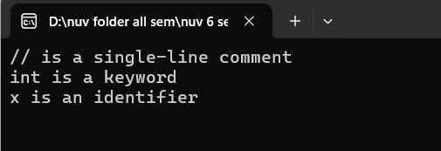

Practical3
To Study about Lexical Analyzer Generator (LEX) and Flex(Fast Lexical Analyzer)

Introduction:
Lexical analysis is the first phase of a compiler, where the source code is converted into a sequence of tokens. Tokens are the basic building blocks of programming languages such as keywords, identifiers, constants, operators, and symbols. Writing a lexical analyzer manually is both time-consuming and error-prone. To address this, tools like LEX and Flex are used to automatically generate efficient lexical analyzers.

LEX and Flex:
LEX is a tool developed for generating lexical analyzers based on patterns described using regular expressions. It reads a given set of rules and produces a C program that can identify the corresponding lexical elements in the input stream.
Flex (Fast Lexical Analyzer) is a free and open-source alternative to LEX. It is compatible with LEX specifications but provides improved performance and additional features. Flex scans the source code using the rules defined in a “.l” file and outputs a C source file that can be compiled to perform token recognition.
Both LEX and Flex are typically used in conjunction with parser generators like YACC or Bison, enabling the seamless integration of lexical and syntax analysis in compiler construction.

Practical4
Sample Program
Input:
%{
#include<stdio.h>
int letters=0;
%}
%%
[a-zA-Z] {letters++;}
\n ;
. ;
%%
void main(){
yyin=fopen("input.txt","r");
yylex();
printf("This file is containing %d letters",letters);
}
int yywrap(){ return(1);}
Text file:

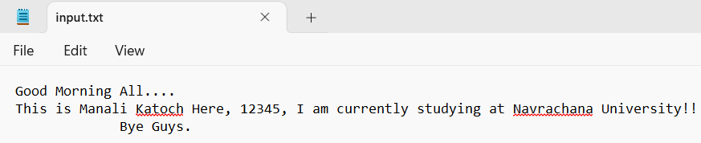

Output:
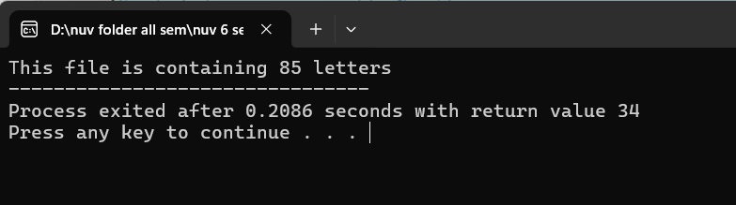

Implement following programs using Lex.
- Write a Lex program to take input from text file and count no of characters, no. of lines & no. of words.
Input:
%{
#include <stdio.h>
int char_count = 0, word_count = 0, line_count = 0;
%}
%%
\n { line_count++; char_count++; }
[^\n\t ]+ { word_count++; char_count += yyleng; }
. { char_count++; }
%%
int main() {
FILE *file = fopen("input.txt", "r"); // Open the file
if (!file) {
printf("Error: Could not open file 'input.txt'\n");
return 1;
}
yyin = file; // Set Lex input to the file
yylex(); // Process the file
printf("\nNumber of Characters: %d", char_count);
printf("\nNumber of Words: %d", word_count);
printf("\nNumber of Lines: %d\n", line_count);
fclose(file); // Close the file
return 0;
}
int yywrap() {
return 1;
}
Output:
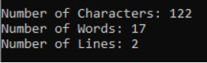

- Write a Lex program to take input from text file and count number of vowels and consonants.
Input:
Lex Code [count1.l]
%{
int vowels = 0;
int consonants = 0;
FILE *yyin;
%}

%%

[aeiouAEIOU] { vowels++; }
[a-zA-Z] { consonants++; }
.|\n { /* Ignore other characters */ }

%%
int yywrap() {
return 1;
}
int main(int argc, char *argv[]) {
if (argc < 2) {
printf("Usage: %s input2.txt\n", argv[0]);
return 1;
}

FILE *file = fopen(argv[1], "r");
if (!file) {
printf("Cannot open file %s\n", argv[1]);
return 1;
}

yyin = file;
yylex();

printf("Number of vowels: %d\n", vowels);
printf("Number of consonants: %d\n", consonants);

fclose(file);
return 0;
}

Input2.txt Code:
Hello World!
Lex is fun.
123
Manali Katoch born on 16 Dec 2003
Output:
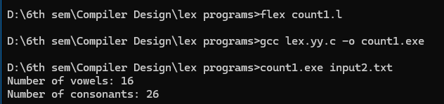

- Write a Lex program to print out all numbers from the given file.
Input:
Lex Code [numbers.l]
%{
#include <stdio.h>
%}

%%

[0-9]+(\.[0-9]+)? { printf("Number found: %s\n", yytext); }
.|\n { /* Ignore all other characters */ }

%%

int yywrap() {
return 1;
}

int main() {
yylex(); // Start the lexical analysis
return 0;
}

Input2.txt Code:
Hello World!
Lex is fun.
123
Manali Katoch born on 16 Dec 2004
Output:
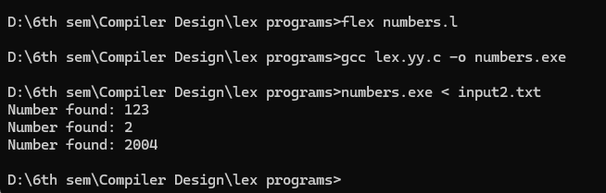

- Write a Lex program which adds line numbers to the given file and display the same into different file.
Input:
%{
#include<stdio.h>
int i = 0;
char line[1000]; // Buffer to store line content
int line_pos = 0; // Position in line buffer
%}
%%
[^\n] {line[line_pos++] = yytext[0];}
[\n] {i++; line[line_pos] = '\0';fprintf(yyout, "%d - %s\n", i, line);line_pos = 0;}
%%
int main() {
yyin = fopen("input.txt", "r");

yyout = fopen("output.txt", "w");

yylex();

fclose(yyin);
fclose(yyout);
return 0;
}
int yywrap() {
return 1;
}
Output:
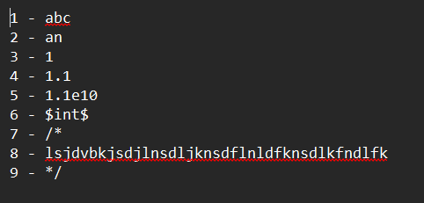
- Write a Lex program to printout all markup tags and HTML comments in file.
Input:
Lex Code [tags_comments.l]
%{
#include <stdio.h>
%}

%%

"<!--"([^>]|[\n])*"-->" { printf("HTML Comment found: %s\n", yytext); }
"<"[a-zA-Z][a-zA-Z0-9]*">" { printf("Opening Tag found: %s\n", yytext); }
"</"[a-zA-Z][a-zA-Z0-9]*">" { printf("Closing Tag found: %s\n", yytext); }
"<"[a-zA-Z][^>]*"/>" { printf("Self-closing Tag found: %s\n", yytext); }

.|\n { /* Ignore other content */ }

%%

int yywrap() { return 1; }

int main() {
yylex();
return 0;
}
input3.html code:
<html>
<head>
<!-- This is a comment -->
<title>Page Title</title>
</head>
<body>
<p>Welcome to the page!</p>
<!-- Another comment -->
</body>
</html>
Output:
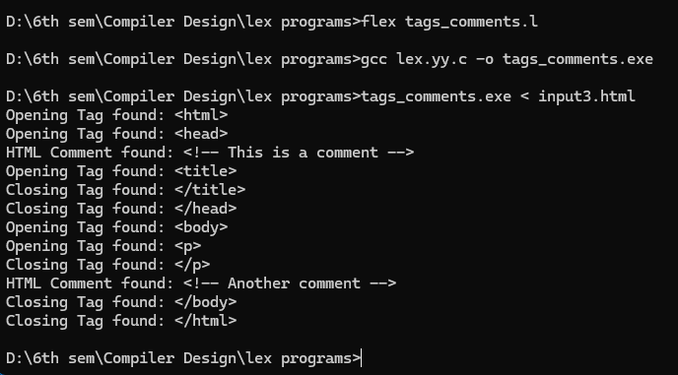

Practical5
- Write a Lex program to count the number of C comment lines from a given C program. Also eliminate them and copy that program into separate file.
Input:
%{
#include <stdio.h>
int c=0;
%}
%%
"/"[^*/]*"/" {fprintf(yyout, "");c++;}
"//".* {fprintf(yyout," ");c++;}
.*fprintf(yyout,"%s",yytext);
%%
int main()
{
yyin=fopen("code.txt","r");
yyout=fopen("output.txt","w");
yylex();
printf("%d comments",c);
}
int yywrap() {return(1);}

Output:
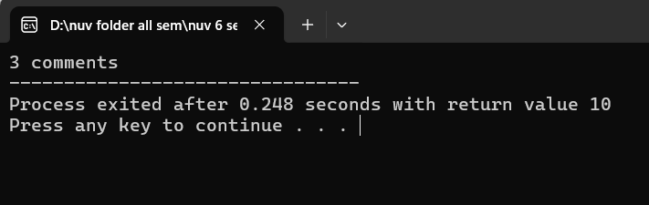
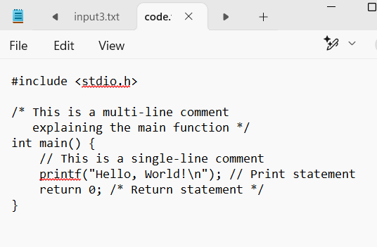
- Write a Lex program to recognize keywords, identifiers, operators, numbers, special symbols, literals from a given C program.
Input:
tokenizer.l
%{
#include <stdio.h>
#include <stdlib.h>
%}

DIGIT [0-9]
LETTER [a-zA-Z]
IDENTIFIER {LETTER}({LETTER}|{DIGIT})*
NUMBER {DIGIT}+(\.{DIGIT}+)?
OPERATOR [+\-*/%=><|&!]
SPECIAL [(){}[\];,]
LITERAL \"(\\.|[^"\\])*\"

%%

"auto" { printf("Keyword: %s\n", yytext); }
"break" { printf("Keyword: %s\n", yytext); }
"case" { printf("Keyword: %s\n", yytext); }
"char" { printf("Keyword: %s\n", yytext); }
"const" { printf("Keyword: %s\n", yytext); }
"continue" { printf("Keyword: %s\n", yytext); }
"default" { printf("Keyword: %s\n", yytext); }
"do" { printf("Keyword: %s\n", yytext); }
"double" { printf("Keyword: %s\n", yytext); }
"else" { printf("Keyword: %s\n", yytext); }
"enum" { printf("Keyword: %s\n", yytext); }
"extern" { printf("Keyword: %s\n", yytext); }
"float" { printf("Keyword: %s\n", yytext); }
"for" { printf("Keyword: %s\n", yytext); }
"goto" { printf("Keyword: %s\n", yytext); }
"if" { printf("Keyword: %s\n", yytext); }
"int" { printf("Keyword: %s\n", yytext); }
"long" { printf("Keyword: %s\n", yytext); }
"register" { printf("Keyword: %s\n", yytext); }
"return" { printf("Keyword: %s\n", yytext); }
"short" { printf("Keyword: %s\n", yytext); }
"signed" { printf("Keyword: %s\n", yytext); }
"sizeof" { printf("Keyword: %s\n", yytext); }
"static" { printf("Keyword: %s\n", yytext); }
"struct" { printf("Keyword: %s\n", yytext); }
"switch" { printf("Keyword: %s\n", yytext); }
"typedef" { printf("Keyword: %s\n", yytext); }
"union" { printf("Keyword: %s\n", yytext); }
"unsigned" { printf("Keyword: %s\n", yytext); }
"void" { printf("Keyword: %s\n", yytext); }
"volatile" { printf("Keyword: %s\n", yytext); }
"while" { printf("Keyword: %s\n", yytext); }

{IDENTIFIER} { printf("Identifier: %s\n", yytext); }
{NUMBER} { printf("Number: %s\n", yytext); }
{OPERATOR} { printf("Operator: %s\n", yytext); }
{SPECIAL} { printf("Special Symbol: %s\n", yytext); }
{LITERAL} { printf("Literal: %s\n", yytext); }

[ \t\n] { /* Ignore whitespace and newlines */ }

. { printf("Unknown Token: %s\n", yytext); }

%%

int yywrap() {
return 1;
}

int main() {
yylex();
return 0;
}

input4.txt
int main() {
int a = 10, b = 20;
float c = 3.14;
char d = 'x';
printf("Hello, World!\n");

return 0;
}
Output:
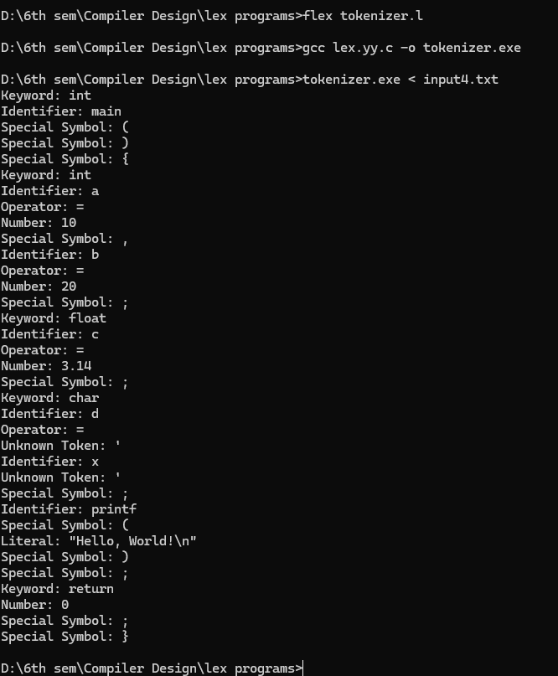

Practical6
Program to implement Recursive Descent Parsing in C.
Input:
Code:
#include <stdio.h>
#include <string.h>
#define SUCCESS 1
#define FAILED 0
// Function prototypes
int E(), Edash(), T(), Tdash(), F();
const char *cursor;
char string[64];
int main()
{
puts("Enter the string");
scanf("%s", string); // Read input from the user
cursor = string;
puts("");
puts("Input Action");
puts("--------------------------------");
// Call the starting non-terminal E
if (E() && *cursor == '\0')
{ // If parsing is successful and the cursor has reached the end
puts("--------------------------------");
puts("String is successfully parsed");
return 0;
}
else
{
puts("--------------------------------");
puts("Error in parsing String");
return 1;
}
}
// Grammar rule: E -> T E'
int E()
{
printf("%-16s E -> T E'\n", cursor);
if (T())
{ // Call non-terminal T
if (Edash())
{ // Call non-terminal E'
return SUCCESS;
}
else
{
return FAILED;
}
}
else
{
return FAILED;
}
}
// Grammar rule: E' -> + T E' | $
int Edash()
{
if (*cursor == '+')
{
printf("%-16s E' -> + T E'\n", cursor);
cursor++;

if (T())
{ // Call non-terminal T
if (Edash())
{ // Call non-terminal E'
return SUCCESS;
}
else
{
return FAILED;
}
}
else
{
return FAILED;
}
}
else
{
printf("%-16s E' -> $\n", cursor);
return SUCCESS;
}
}
// Grammar rule: T -> F T'
int T()
{
printf("%-16s T -> F T'\n", cursor);
if (F())
{ // Call non-terminal F
if (Tdash())
{ // Call non-terminal T'
return SUCCESS;
}
else
{
return FAILED;
}
}
else
{
return FAILED;
}
}

// Grammar rule: T' -> * F T' | $
int Tdash()
{
if (*cursor == '*')
{
printf("%-16s T' -> * F T'\n", cursor);
cursor++;

if (F())
{ // Call non-terminal F
if (Tdash())
{ // Call non-terminal T'
return SUCCESS;
}
else
{
return FAILED;
}
}
else
{
return FAILED;
}
}
else
{
printf("%-16s T' -> $\n", cursor);
return SUCCESS;
}
}
// Grammar rule: F -> ( E ) | i
int F()
{
if (*cursor == '(')
{
printf("%-16s F -> ( E )\n", cursor);
cursor++;
if (E())
{ // Call non-terminal E
if (*cursor == ')')
{
cursor++;
return SUCCESS;
}
else
{
return FAILED;
}
}
else
{
return FAILED;
}
}
else if (*cursor == 'i')
{
printf("%-16s F -> i\n", cursor);
cursor++;
return SUCCESS;
}
else
{
return FAILED;
}
}

Output:
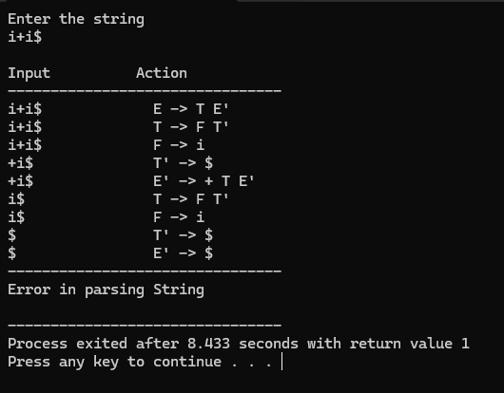
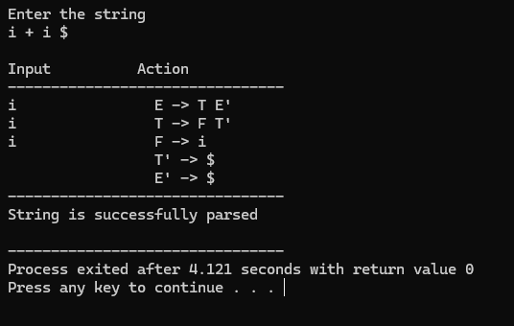
Practical-7
a.To Study about Yet Another Compiler-Compiler(YACC).
Input:
What is YACC?
- YACC (Yet Another Compiler-Compiler) is a tool used in compiler design to generate parsers. It helps you build the syntax analysis part of a compiler.
- It was developed by Stephen C. Johnson at AT&T Bell Labs.

Why is YACC used?
- Writing a parser manually (like recursive descent) is complex and error-prone.
- YACC automates this by generating C code for the parser from a grammar specification.
- It works well with lex, the lexical analyzer generator.

How does YACC work?
- You write a grammar using BNF (Backus-Naur Form) or similar syntax.
- You assign semantic actions to grammar rules (using C code).
- YACC generates a parser in C that uses a bottom-up parsing algorithm (usually LALR(1)).
- The parser works with lex to analyze tokens.

Structure of a YACC file
A YACC source file has three sections, separated by %%:

%{
// Declarations (C code, headers)
%}

%token ID NUM // Token definitions

%%

E : E '+' T { printf("Adding\n"); }
| T { /* do nothing */ }
;

T : T '*' F { printf("Multiplying\n"); }
| F { /* do nothing */ }
;

F : '(' E ')'
| ID
| NUM
;

%%

// Additional C code (main function etc.)

YACC and LEX Integration
- LEX handles scanning/tokenizing (splits input into tokens).
- YACC handles parsing (checks if token sequence is valid as per grammar).
- They work together to build front ends for compilers.
Advantages of YACC
- Speeds up parser development.
- Helps build robust parsers for programming languages.
- Well-suited for formal language processing tasks.

- Create Yacc and Lex specification files to recognizes arithmetic expressions involving +, -, * and / .

expr.l code:
%{
#include "expr.tab.h"
#include <stdlib.h>
%}

%%

[0-9]+ { yylval.ival = atoi(yytext); return NUMBER; }
[a-zA-Z]+ { yylval.ival = 0; return ID; }
[ \t]+ ; // skip whitespace
\n { return '\n'; }
. { return yytext[0]; }

%%

int yywrap() {
return 1;
}

expr.y code:
%{
#include <stdio.h>
#include <stdlib.h>

void yyerror(const char *s);
int yylex(void);
%}

%union {
int ival;
}

%token <ival> NUMBER
%token <ival> ID
%type <ival> E

%left '+' '-'
%left '*' '/'

%%

input:
E '\n' { printf("Result = %d\n", $1); }
;

E:
E '+' E { $$ = $1 + $3; }
| E '-' E { $$ = $1 - $3; }
| E '*' E { $$ = $1 * $3; }
| E '/' E { $$ = $1 / $3; }
| '-' E { $$ = -$2; }
| '(' E ')' { $$ = $2; }
| NUMBER { $$ = $1; }
| ID { $$ = $1; }
;

%%

int main(void) {
printf("Enter the expression:\n");
yyparse();
return 0;
}

void yyerror(const char *s) {
fprintf(stderr, "Error: %s\n", s);
}
Output:
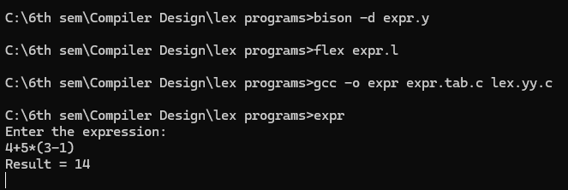
b.Create Yacc and Lex specification files to recognizes arithmetic expressions involving +, -, * and / .
Input:
YACC:
%{
#include<stdlib.h>
#include<stdio.h>
#include<string.h>
void yyerror(char *);
int yylex(void);
extern FILE *yyin;
%}
%union{
char *str;
int num;
}
%token <str> ID
%token <num> INT
%left '+' '-'
%left '*' '/'
%%
S:E '\n' {printf("The string is valid.");}
E:E '+' T { }
| E '-' T { }
| T { }
T:T '*' F { }
| T '/' F { }
| F { }
F:INT { }
| ID { }
%%
void yyerror(char *s){
fprintf(stderr,"%s\n",s);
}
int main(int argc, char **argv){
if(argc<2){
printf("Usage: %s <input>",argv[0]);
exit(1);
}

FILE *input = fopen(argv[1],"r");
if(!input){
printf("Error Opening File.");
exit(1);
}
yyin=input;
yyparse();
fclose(input);
return 0;
}
LEX:
%{
#include<stdlib.h>
#include<stdio.h>
#include<string.h>
void yyerror(char *);
#include "yacc.tab.h"
%}
%%
[0-9]+ {yylval.num=atoi(yytext); return INT;}
[A-Za-z][A-Za-z0-9_]* {yylval.str=strdup(yytext); return ID;}
[-+*/] {return *yytext;}
\n {return '\n';}
[ \t] { }
. {yyerror("Invalid input.");}
%%
int yywrap(){return 0;}
INPUT.txt:
1+2+3+5+8
Output:
c.Create Yacc and Lex specification files are used to generate a calculator which accepts integer type arguments.
Input:
calc.l code:

%{
#include "calc.tab.h"
#include <stdlib.h>
%}

%%

[0-9]+ { yylval.ival = atoi(yytext); return NUMBER; }
[ \t]+ ; // skip whitespace
\n { return '\n'; }
. { return yytext[0]; }

%%

int yywrap() {
return 1;
}

calc.y code:

%{
#include <stdio.h>
#include <stdlib.h>

void yyerror(const char *s);
int yylex(void);
%}

%union {
int ival;
}

%token <ival> NUMBER
%type <ival> expr

%left '+' '-'
%left '*' '/'
%start input

%%

input:
expr '\n' { printf("Result = %d\n", $1); }
;

expr:
expr '+' expr { $$ = $1 + $3; }
| expr '-' expr { $$ = $1 - $3; }
| expr '*' expr { $$ = $1 * $3; }
| expr '/' expr {
if ($3 == 0) {
yyerror("Division by zero");
YYABORT; // Exit the parsing process immediately
} else {
$$ = $1 / $3;
}
}
| '(' expr ')' { $$ = $2; }
| NUMBER { $$ = $1; }
;

%%

int main() {
printf("Enter the expression:\n");
return yyparse();
}

void yyerror(const char *s) {
fprintf(stderr, "Error: %s\n", s);
}
Output:
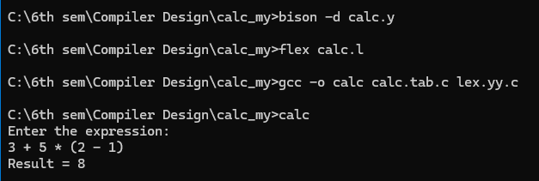
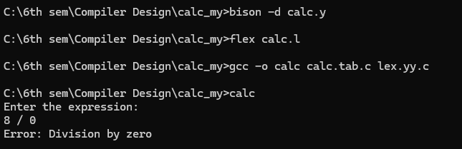
d. Create Yacc and Lex specification files are used to convert infix expression to postfix expression.
Input:
infix_to_postfix.l code:

%{
#include "infix_to_postfix.tab.h"
#include <stdlib.h>
#include <string.h>
%}

DIGIT [0-9]
WS [ \t\r]+

%%

{DIGIT}+ {
yylval.str = strdup(yytext);
return NUMBER;
}
"(" { return '('; }
")" { return ')'; }
"+" { return '+'; }
"-" { return '-'; }
"*" { return '*'; }
"/" { return '/'; }
{WS} { /* skip whitespace */ }
\n { return '\n'; }
. { return yytext[0]; }

%%

int yywrap() {
return 1;
}

infix_to_postfix.y code:

%{
#include <stdio.h>
#include <stdlib.h>
#include <string.h>
#include <stdarg.h>

// custom asprintf implementation for Windows
int asprintf(char **strp, const char *fmt, ...) {
va_list args;
va_start(args, fmt);
int size = vsnprintf(NULL, 0, fmt, args);
va_end(args);

if (size < 0) return -1;

*strp = (char *)malloc(size + 1);
if (!*strp) return -1;

va_start(args, fmt);
vsnprintf(*strp, size + 1, fmt, args);
va_end(args);

return size;
}

void yyerror(const char *s);
int yylex(void);
%}

%union {
char *str;
}

%token <str> NUMBER
%left '+' '-'
%left '*' '/'
%token '(' ')'

%type <str> expr

%%

input:
/* empty */
| input expr '\n' {
printf("Postfix: %s\n", $2);
free($2);
}
;

expr:
NUMBER { $$ = strdup($1); free($1); }
| expr '+' expr { asprintf(&$$, "%s %s +", $1, $3); free($1); free($3); }
| expr '-' expr { asprintf(&$$, "%s %s -", $1, $3); free($1); free($3); }
| expr '*' expr { asprintf(&$$, "%s %s *", $1, $3); free($1); free($3); }
| expr '/' expr { asprintf(&$$, "%s %s /", $1, $3); free($1); free($3); }
| '(' expr ')' { $$ = $2; }
;

%%

void yyerror(const char *s) {
fprintf(stderr, "Error: %s\n", s);
}

int main() {
printf("Enter an infix expression:\n");
yyparse();
return 0;
}
Output:
